**PIZZA SALES DATA EXPLORATION QUERIES AND RESULTS**

1. No of records

select count(*) from pizza_sales;

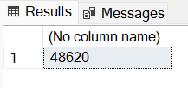

1. No of distinct records

select count(distinct pizza_id)

from pizza_sales;



1. Period Year

select distinct(datepart(year, order_date))

from pizza_sales;

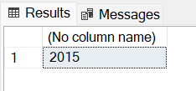

1. Does data account for all months?

select distinct(datepart(month, order_date))

from pizza_sales

order by 1;

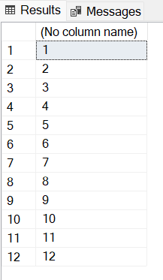

KPI

1. Total Revenue

select cast(sum(total_price) as decimal(10,2)) as total_revenue

from pizza_sales;

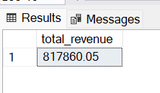

1. Average Order Value

select cast((sum(total_price) / count(distinct order_id)) as decimal(10,2)) as avg_order_value

from pizza_sales;

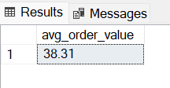

1. Total Pizzas Sold

select sum(quantity) as total_pizza_sold

from pizza_sales;

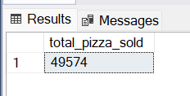

1. Total Orders

select count(distinct order_id) as total_orders

from pizza_sales;

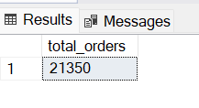

1. Average Pizzas per Order

select cast(sum(quantity) / cast(count(distinct order_id) as decimal(10,2)) as decimal(10,2)) as avg_pizza_per_order

from pizza_sales;

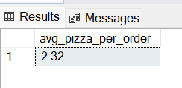

CHART REQUIREMENTS

1. Daily trends for Total Order

select datename(dw, order_date) as order_day, sum(quantity) as no_of_orders

from pizza_sales

group by datename(dw, order_date)

order by 1;

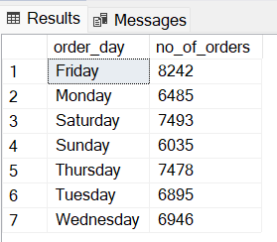

1. Hourly trends for Total Order

select datepart(hour, order_time) as hour, sum(quantity) as no_of_orders

from pizza_sales

group by datepart(hour, order_time)

order by 1;

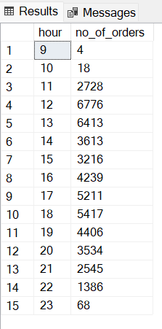

1. Percentage sales per Pizza Category

select pizza_category, cast(sum(total_price) as decimal(10,2)) as total_sales,

cast((sum(total_price)/(select sum(total_price) from pizza_sales)) * 100 as decimal(10,2)) as percentage_sales

from pizza_sales

group by pizza_category;

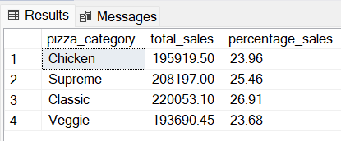

1. Percentage sales per Pizza Size

select pizza_size, cast(sum(total_price) as decimal(10,2)) as total_sales,

cast((sum(total_price)/(select sum(total_price) from pizza_sales)) * 100 as decimal(10,2)) as percentage_sales

from pizza_sales

group by pizza_size

order by 3;

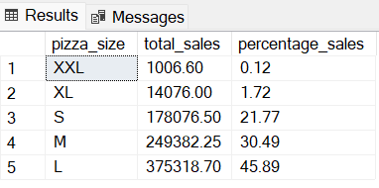

1. Percentage sales per Pizza Size per quarter

select pizza_size, cast(sum(total_price) as decimal(10,2)) as total_sales,

cast((sum(total_price)/(

select sum(total_price)

from pizza_sales

where datepart(quarter, order_date) = 3

)) * 100 as decimal(10,2)) as percentage_sales

from pizza_sales

where datepart(quarter, order_date) = 3

group by pizza_size

order by 3;

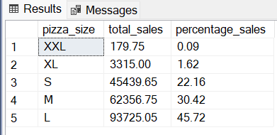

1. Total Pizza sold by Category

select pizza_category, sum(quantity) as total_pizza_sold

from pizza_sales

group by pizza_category;

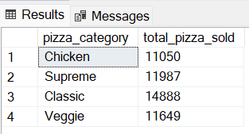

1. Top best sellers by Pizzas sold

select top 5

pizza_name, sum(quantity) as total_sold

from pizza_sales

group by pizza_name

order by 2 desc;

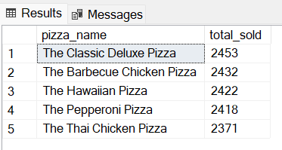

1. Bottom worst sellers by Pizzas sold

select top 5

pizza_name, sum(quantity) as total_sold

from pizza_sales

group by pizza_name

order by 2;

